Project Initialization and planning phase

|  |  |
| --- | --- |
| Date | 20/06/25 |
| Team Id | SWTID1750180744 |
| Project Name | Smart sorting:Transfer Learning for  Identifying Rotten |
| Maximum Marks | 3 Marks |

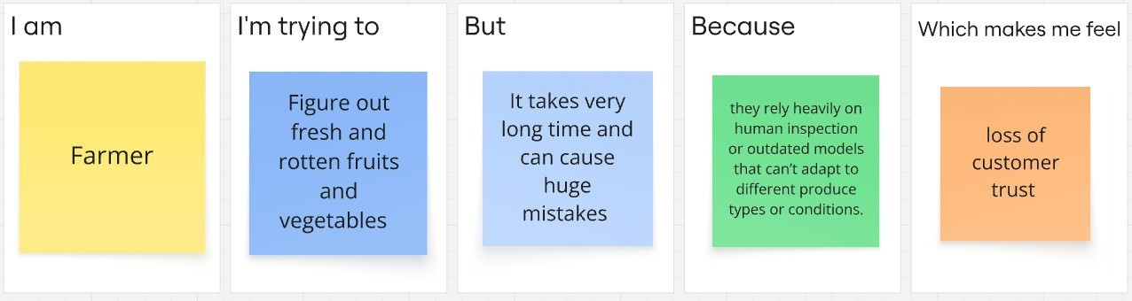Define problem Statement Problem Statement - 1

Problem Statement - 2

